SCORE CAPTURE
LEAGUE SCORING and CAPTAINS VERIFY
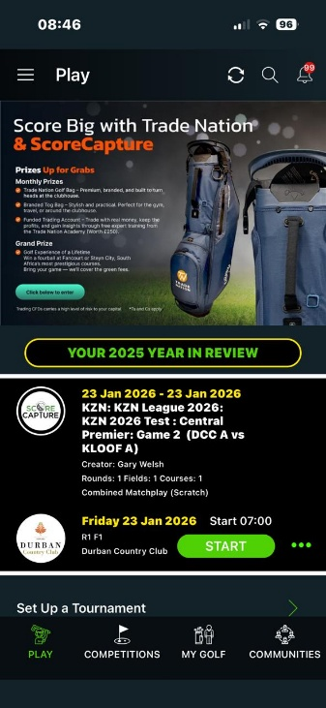
Once the captains have entered their teams into score capture, the players will have access to the fixture on the day of the match. When they open the app each player will get the following screen.

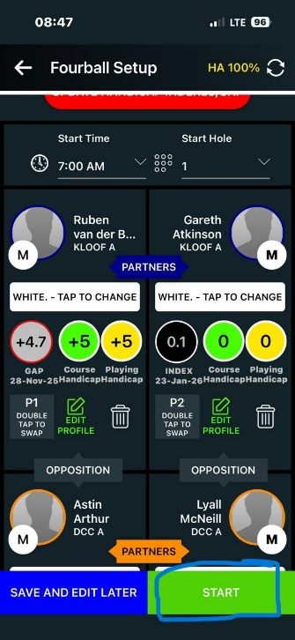
The player will click start on the first screen. The players as entered by the captains will appear on the next screen. Click start to begin scoring.

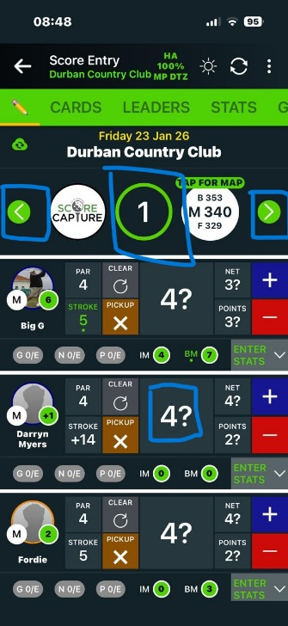

The app will take you to the correct starting hole as setup on the fixtures. You can toggle between holes using the arrows. Whan a score appears with a ? next to the number this means the score has not been entered.

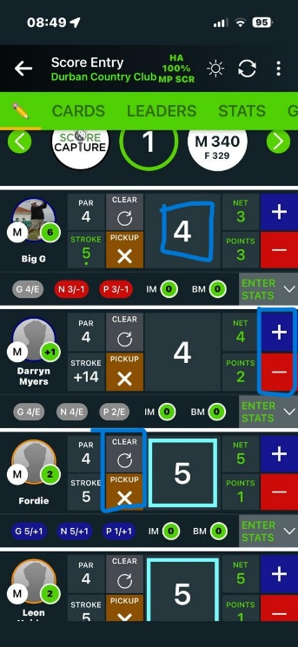

If the player scores a par simply click the number and the ? will disappear. If the player scores a anything other than a par, use the + or – botton to change the score. Clear and Pick up can also be used to correct scores. Pick Up will give you the score you have for handicap purposes should you not complete the hole. To get to the next hole, click the right arrow next to the hole number.

While playing you can check your scores as well as those in other matches. Click on “Leaders” in the above green bar.

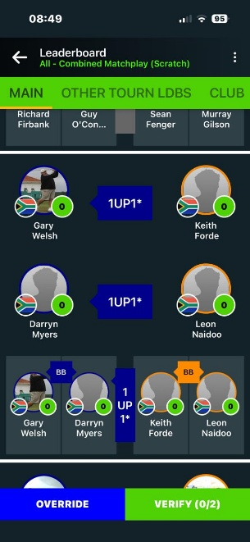

This will give you the status of the game as well as the other matches if you scroll down as well as a projected match score at the top of the page.
Click the back arrow, top left, to get back to your game.

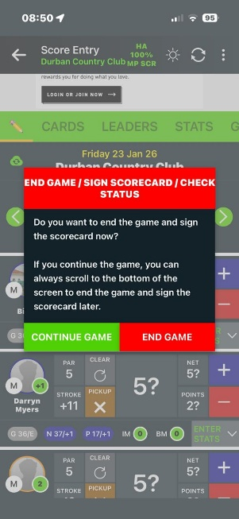

When you scroll to the 10th hole it will ask you to confirm if you will be continuing the game, click continue game.

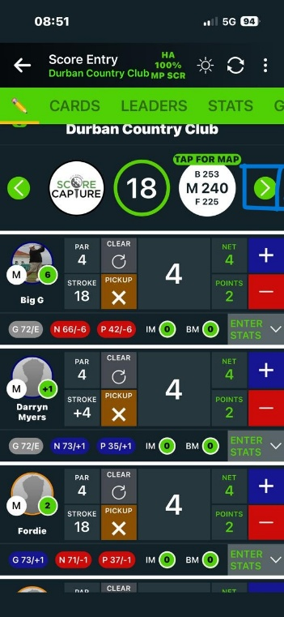

When you get to the 18th hole, click the right arrow.

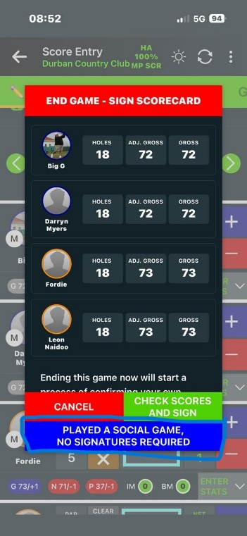

Click on the blue button “No signatures required”. This will bring up another screen asking if you would like to email the scores to the players. You can simply close the app and it will not send the emails.

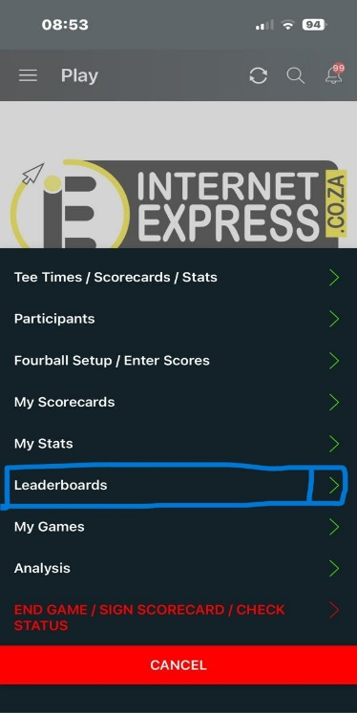
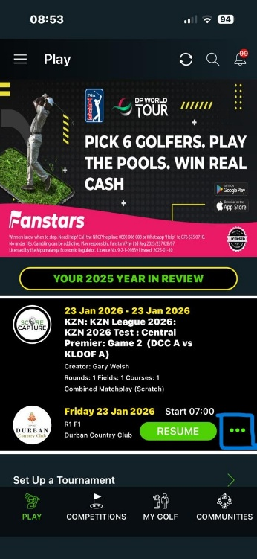

After the game you can re-open the app to follow other matches. Click the three dots, then Leaderboards and this will take you to the status of the other matches, if scored.

FOR CAPTAINS TO VERIFY OR OVERRIDE SCORES (IF NOT SCORED)
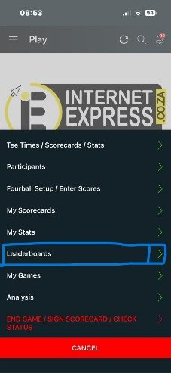
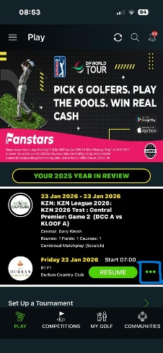

Re-Open the app. Click the three dots, then Leaderboards and this will take you to the status of all the matches.

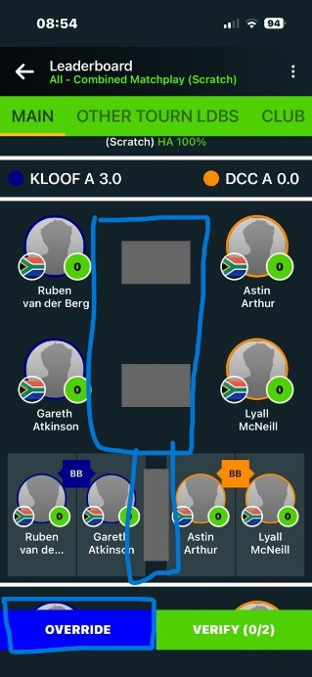

If you see results next to the matches, the players would have scored. If the scores are correct, scroll to the next match and check the scores. If you see a match such as the one on the left, it means the match was not scored live and you can “override the score”.

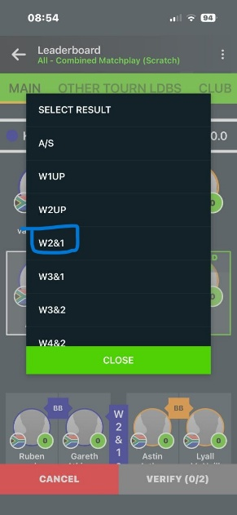
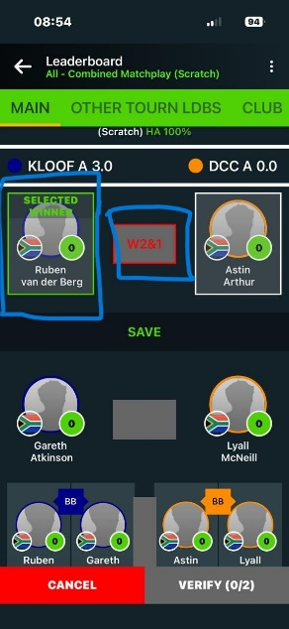
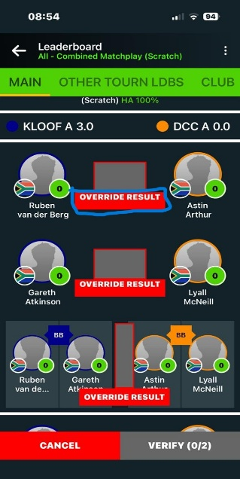

Click override, then override result to enter the match score. First choose who the winner was, then click on the score box and the results list will appear. Choose the result and click close. Then click save.
Do this for each match until all matches have results saved and the match result is correct.

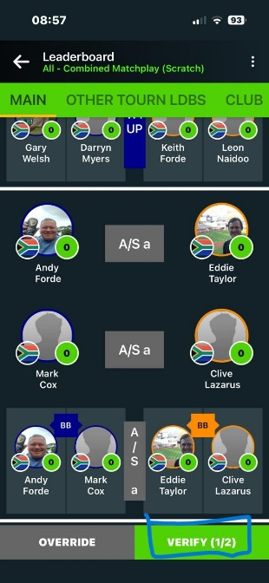
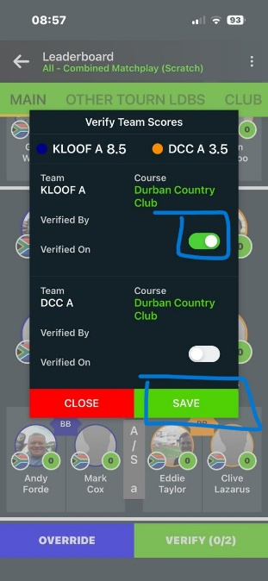
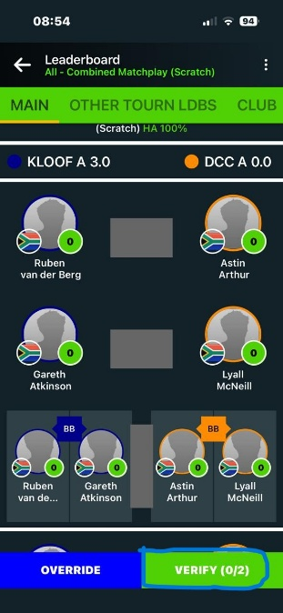

Once you are happy with the scores, click verify. The verify screen will appear and you can toggle the button next to your team and then save.
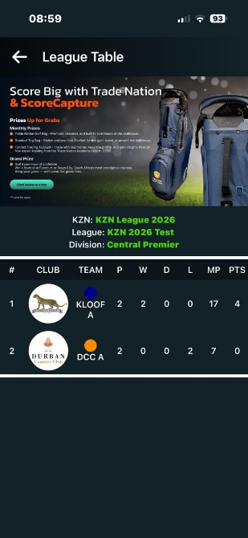
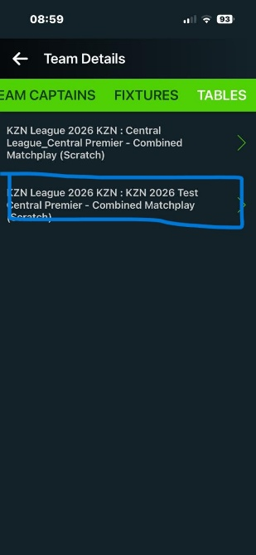
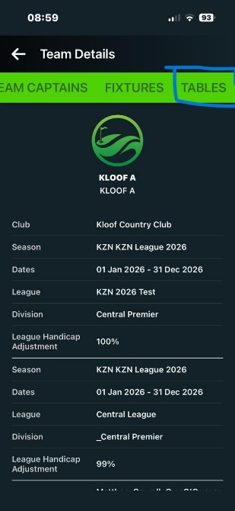
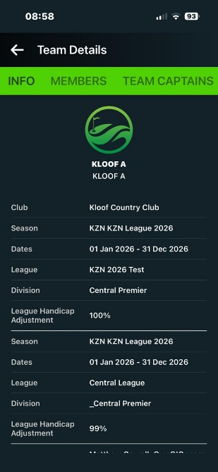
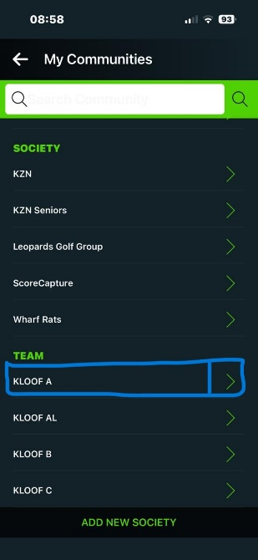
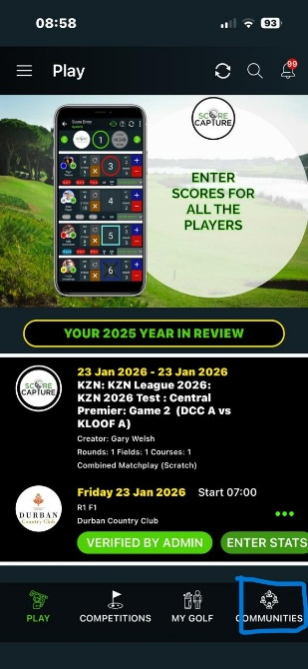
Once you have done this you will see either ½ or 2/2 verified. Once you have done this all has been updated to Score Capture and there is nothing further to do.

Should you or your players want to see the logs you could do the following:
Open the App
- click Communities bottom right
- Click on your team
- Scroll the green bar menu until you see “Tables”

- Click Tables
- Click the league you are in
- The table will appear.

On the same green bar you can also see
your fixtures, both past and future.

I trust this will assist you and your players in using score capture to update and administer the leagues efficiently.
Thank you and great Golfing.

